Assignment 2 – Probability and Statistics

Question 1 –

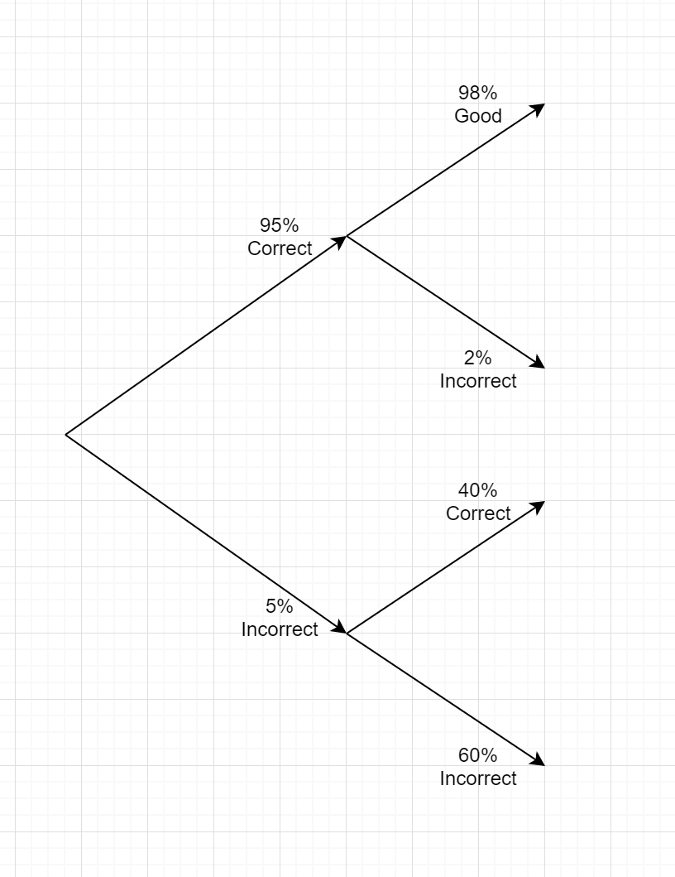

(.95)(.98) = .0931

Question 2 –

1. Yes they are mutually exclusive as a ball bearing can be the incorrect size but the ball bearing cannot be both undersized and oversized simultaneously
2. .004 – oversized and .01 undersized. (.01) + (.004) = .014

The chance of the ball bearing being an irregular size would 1.4%(.014)

1. .014 of the ball bearings are irregular size thus 1 - .014 = .986

98.6%(.986) the ball bearing would be correctly sized

Question 3 –

.014 = 100%

.01 = ?

.01 / .014 = .7142

.7142 * 100 = 71.42%

There is a 71.42% chance that a ball bearing selected from the reject bin will be undersized.

Question 4 –

60% - China

40% Singapore

5% defect from Singapore - .4 * .05 = .02

7% defect from China - .6 * .07 = .042

.042 + .02 = .062

.062 = 100%

.042 / .062 = .6774

.6774 * 100 = 67.74%

There is a 67.74% chance of the defected piece coming from China

Question 5 –

Box 1 – 2 green, 8 red. 10 total

Box 2 – 2 red, 5 green. 7 total

( $\frac{1}{2}$ $\frac{8}{10}$* ) + ( $\frac{1}{2}$ $\frac{2}{7}$* ) = $\frac{8}{20}$ + $\frac{2}{14}$ = $\frac{56}{140}$ + $\frac{20}{140}$ = $\frac{76}{140}$ = $\frac{19}{35}$

The probability of pulling a red ball from box 1 is $\frac{19}{35}$ (.5428)

Question 6 –

{6, 9, 21, 25, 31, 37, 37, 42, 44, 45, 47}

Mean - – $\frac{6 + 9 + 21 + 25 + 31 + 37 + 37 + 42 + 44 + 45+ 47 }{11}$ = $\frac{342}{11}$ = 31.27

Mode – Most Common Value – 37 as it appears twice

Median - $\frac{n+1}{2}$- $\frac{11+1}{2}$ = $\frac{12}{2}$ = 6. The 6th value of the data set is 37.

InterQuartile Range – $\frac{3(n+1)}{4}$- $\frac{3(11+1)}{4}$ = $\frac{3(12)}{4}$ = $\frac{36}{4}$ =9

$\frac{n+1}{4}$ = $\frac{11+1}{4}$ = $\frac{12}{4}$ = 3

The interquartile range is 9 – 3 = 6.

|  |  |  |
| --- | --- | --- |
| x | x-x | $${(x-x)}^{2}$$ |
| 6 | -25.27 | 638.5729 |
| 9 | -22.27 | 495.9529 |
| 21 | -10.27 | 105.4729 |
| 25 | -6.27 | 39.3129 |
| 31 | -.27 | .0729 |
| 37 | 5.73 | 32.8329 |
| 37 | 5.73 | 32.8329 |
| 42 | 10.73 | 115.1329 |
| 44 | 12.73 | 162.0529 |
| 45 | 13.73 | 188.5129 |
| 47 | 15.73 | 247.4329 |

The total is 2058.1819

The square root of $\frac{2058.1819}{11}$ is 13.6787

Question 7 –

$\frac{x-u}{standard deviation}$ = $\frac{850-1000}{90}$ = -1.67 = .9525

1 - .9525 = .0475 = 4.75%

6000 bulbs * 4.75% = 285 bulbs

285 bulbs will fail before 850 hours

Question 8 –

$\frac{x-u}{standard deviation}$ = $\frac{19-28}{6}$ = $\frac{-9}{6}$ = -1.5 = .9332

1 - .9332 = .0668

$\frac{x-u}{standard deviation}$ = $\frac{37-28}{6}$ = $\frac{9}{6}$ = 1.5 = .9332

1 - .9332 = .0668

.9332 - .0668 = .8664

The area greater than 19 and less than 37 is .8664(86.64%)